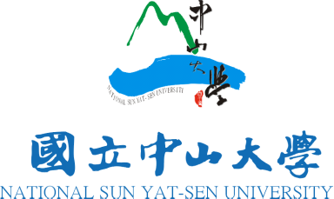
Secretariat of OPTIC 2017
Department of Photonics
National Sun Yat-sen University
No. 70 Lein-Hai Road, Kaohsiung,
Taiwan 804, R. O. C.
Tel:+886-7-525-2000 ext 4451-4452
Fax:+886-7-525-4499
E-mail: optic2017@mail.nsysu.edu.tw

OFFICIAL INVITATION LETTER

2017.03
The Optics & Photonics Taiwan, the International Conference (OPTIC 2017) has served as the largest annual meeting for the significant progress of research and development on optics and photonics in Taiwan. This year, OPTIC 2017 will be held in National Sun Yat-sen University (NSYSU) from December 7 to December 9, which is located along the beautiful Siziwan Bay in southern Taiwan. On behalf of the conference organizing committee, it is our pleasure and honor to invite you to be invited speaker of the sub-session ,” XXXXXX”. We would be most grateful if you could accept our invitation and participate in this meeting and email us the author list, affiliation, title and abstract of your presentation at your earliest convenience, but no later than XXXXXX, 2017. With your excellent achievement in research, we believe your talk and visit will be reflected for the success of OPTIC 2017.
To find more information of the conference, please check the website,”optic2017.conf.tw”. Please encourage your colleagues and students to join this conference. Should you have any suggestions or comments, feel free to contact us at optic2017@mail.nsysu.edu.tw.

Sincerely yours,

Subsession chair Subsession co-chair
Program Committee Chair
Yi-Jen Chiu


